Tomas Tamberg (Gesellschaft der Staudenfreunde, Fachgruppe Hemerocallis)
Zimmerstr. 3
12207 Berlin
Germany
Tel.: +49 30 712 4235
Fax: +49 30 712 02946
e-mail: Dr.T.u.C.Tamberg@t-online.de Berlin, March 2009

Dear European daylily hybridizers,

the trial project for European daylily varieties is now in its tenth year, and again I appeal to you to participate by sending plants of your daylily creations to the following three gardens for trial:

- Schau- und Sichtungsgarten Hermannshof e.V.
z.Hd. Herrn C. Schmidt
Babostr. 5
69469 Weinheim/Bergstraße
Germany
Tel.:06201 13652

- Henk Wentink
Dorpersveld 606
7327 BJ Apeldoorn
The Netherlands
Tel.: 0031-555413184

- Cottbuser Gartenschau-Gesellschaft 1995 mbH
z.Hd. Frau Gomolka
Vorparkstr. 2
0342 Cottbus
Germany
Tel.: 0355 7529109

The following rules apply to participation:

- Sending plants should be done during April, preferably during the first two weeks of April.
- Of each registered variety or seedling one plant should be sent to each of the three gardens mentioned above. Varieties that are not sent to all three garden will not be judged.
c) A maximum of three registered varieties or seedlings can be sent by each hybrid-
izer per year. (In response to the volume of plants sent, this number may, in fu-
ture years, be adjusted to the space available for planting.)
- The plants sent should have one strong main fan of flowering size and not more than two side fans of non-flowering size. (Sending small fans, that are just able to produce a weak stem and are then exhausted, is not recommended.)
- The plants should be clearly labelled, showing only the seedling number of the variety (even in case of registered varieties) as well as the colour of the flower and the height of the stem. On an enclosed sheet of paper the breeder shall describe for each entry the novelty value or progress aspects according to his personal opinion ¹⁾. Additionally, a plant should be declared as “landscape variety“, if applicable.
- After the completion of the trial the plants are removed from the trial planting. If no deviating decision of the hybridizer exists, the plant material can be discarded or be used in other parts of the gardens hosting the trials. However the plants can only be sold or distributed otherwise on the basis of a written agreement with the breeder. In special cases the breeders can request, that the plant material of a variety is sent back to him, but he has to pay for transport and packing. The request for sending a variety back has to reach the trial garden not later than 14 days after the publication of the trial results.
- Pollen or seeds can only be taken from the trial plants by persons having a written permission of the breeder.
- In case one of the trial plants wins an award, its hybridizer is obliged to register it as a named variety, if this is not already done.

In case you consider the declaration of one of your varieties as „landscape variety“ you should study the following list of qualities which, as the whole, have to be present in such a variety to some extent:
- Healthy leaves during all the growing season
- Marked mass and long distance effect of flower colour
- Flowers high above the leaves
- Stems wiry and rigid
- Floriferousness
- Flowers resistant against weather impacts
- Easy to propagate (underground runners no disadvantage)
- Inconspicuous fading behaviour
In contrast to this, special aspects of flower colour, flower shape and flower size are of lower importance in this group.
I am sure that you have a number of excellent trial candidates in your own gardens and I hope that you can make up your mind to take part in the trials with either brand-new seedlings or with reliable, named varieties of which you are sure that they could be good competitors.

If you should need additional information about the point system applied during judging, you may ask me for a copy of the relevant paper.

Yours sincerely

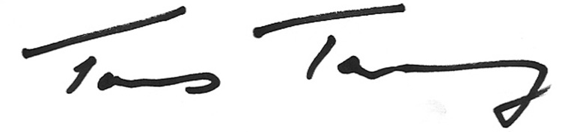
(Tomas Tamberg)

1) Novelty value and progress aspects are not necessarily extraordinary flower colours, colour patterns and flower shapes, but could also be aspects of being especially floriferous or vigorous or showing excellent leaf quality, branching or balanced structure as a garden plant.

